WaterꢀforꢀLifeꢀ- Malawi
FiveꢀSustainableꢀWells
RotaryꢀFoundationꢀGlobalꢀGrantꢀGG2688284


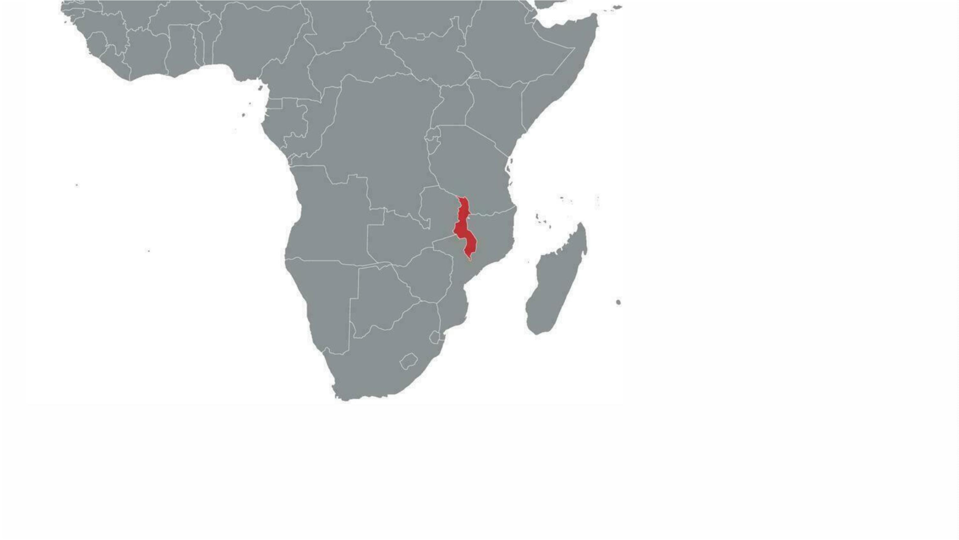

OurꢀPartnerꢀ- VillagesꢀInꢀPartnership
•
•
2008ꢀ- LizꢀHeinzel-Nelsonꢀandꢀherꢀhusbandꢀmovedꢀtheirꢀfamilyꢀtoꢀ
Malawiꢀforꢀaꢀyearꢀofꢀmissionꢀwork;ꢀestablishedꢀVillagesꢀInꢀPartnership.
VIP'sꢀmission:ꢀtoꢀpartnerꢀwithꢀcommunities,ꢀbuildingꢀonꢀtheirꢀexistingꢀ
strengthꢀandꢀdetermination.
•
•
6ꢀU.S.ꢀstaff,ꢀ22ꢀMalawiꢀstaff
SixꢀFocusꢀAreas:ꢀWater,ꢀFoodꢀSecurity,ꢀEducation,ꢀHealthcare,ꢀ
Infrastructure,ꢀEconomicꢀOpportunity


NineꢀPreviousꢀWellsꢀwithꢀVIP
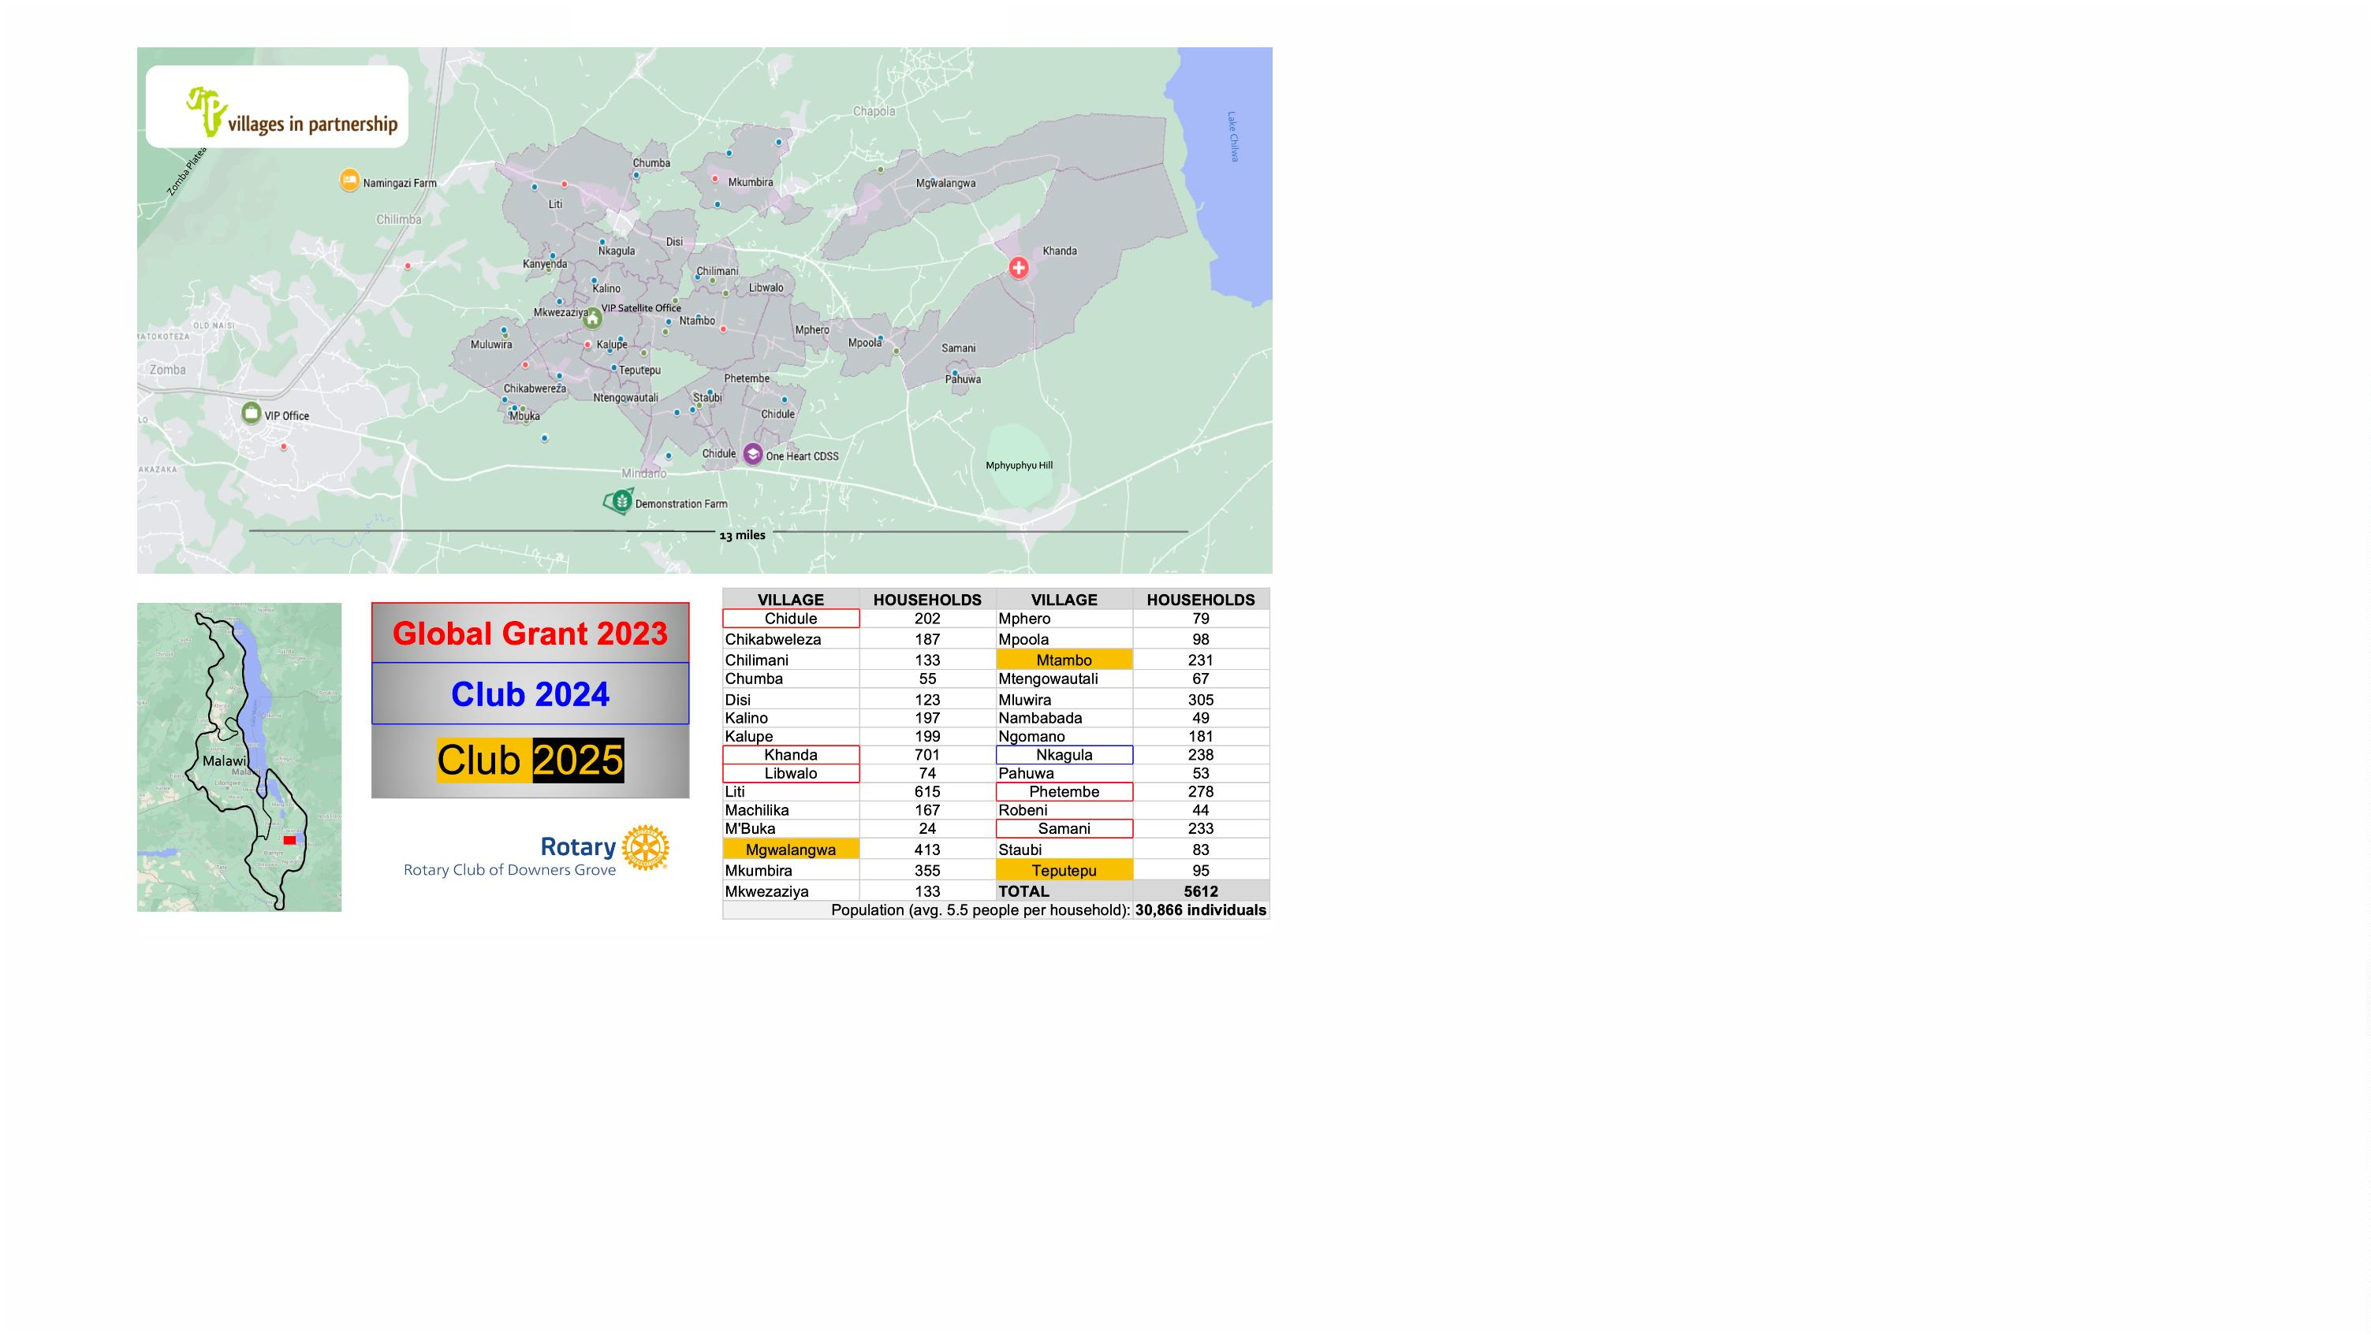

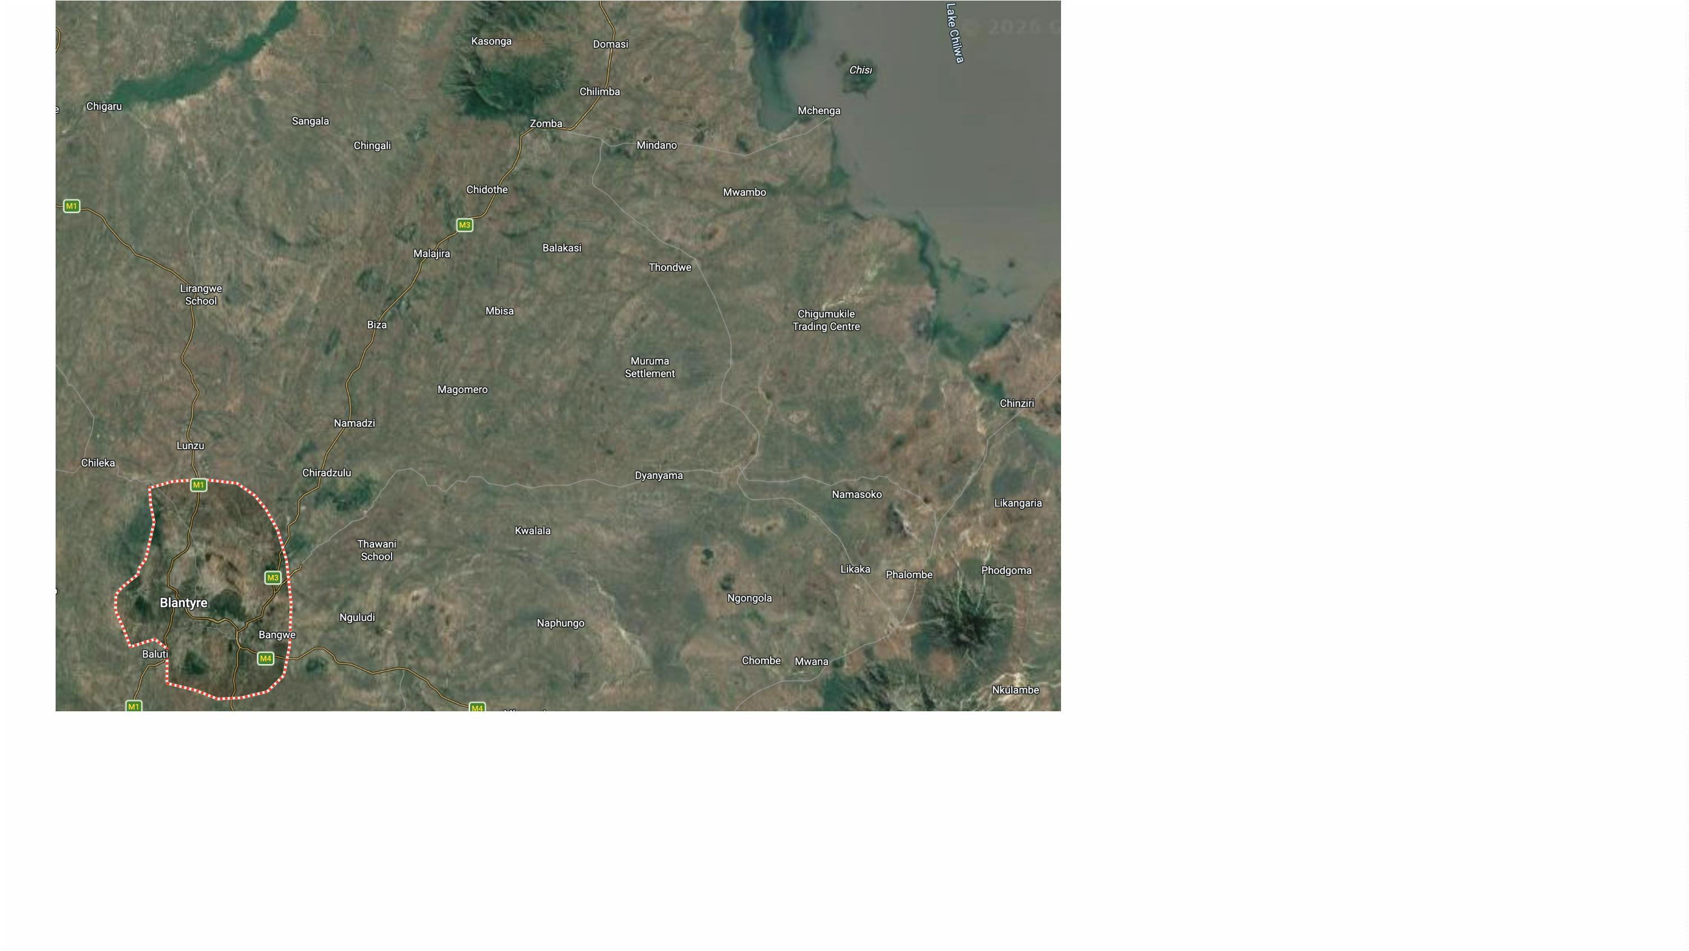

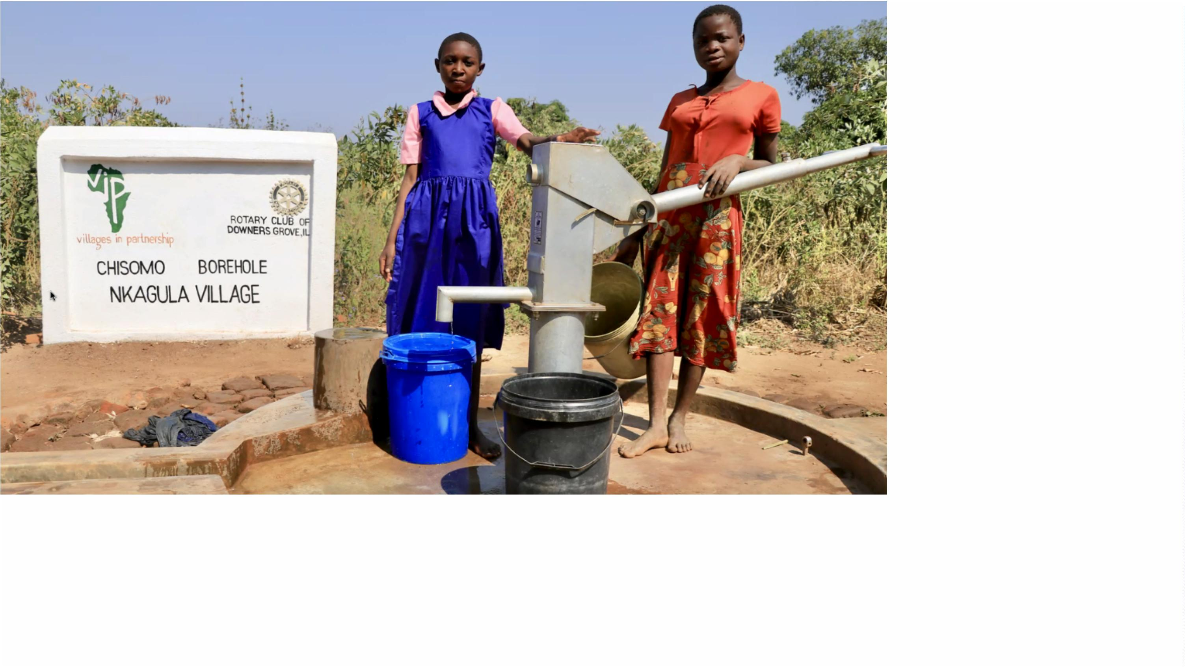

HowꢀdidꢀDGꢀfirstꢀconnectꢀwithꢀVIP?
•
•
•
LizꢀHeinzel-NelsonꢀhasꢀaꢀrelativeꢀinꢀChristchurchꢀofꢀOakbrook
HarryꢀMcCabeꢀ– Rotarianꢀsinceꢀ‘78ꢀ- connectedꢀw/VIPꢀthroughꢀhim
2021ꢀ– Harryꢀinitiatedꢀaꢀglobalꢀgrant


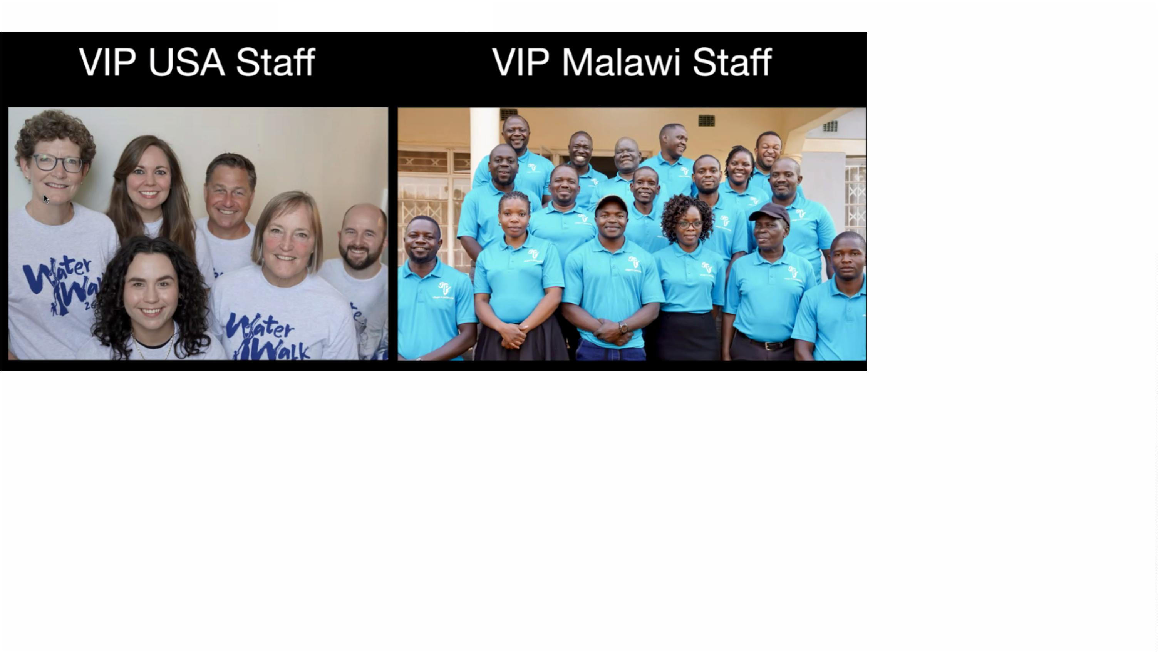

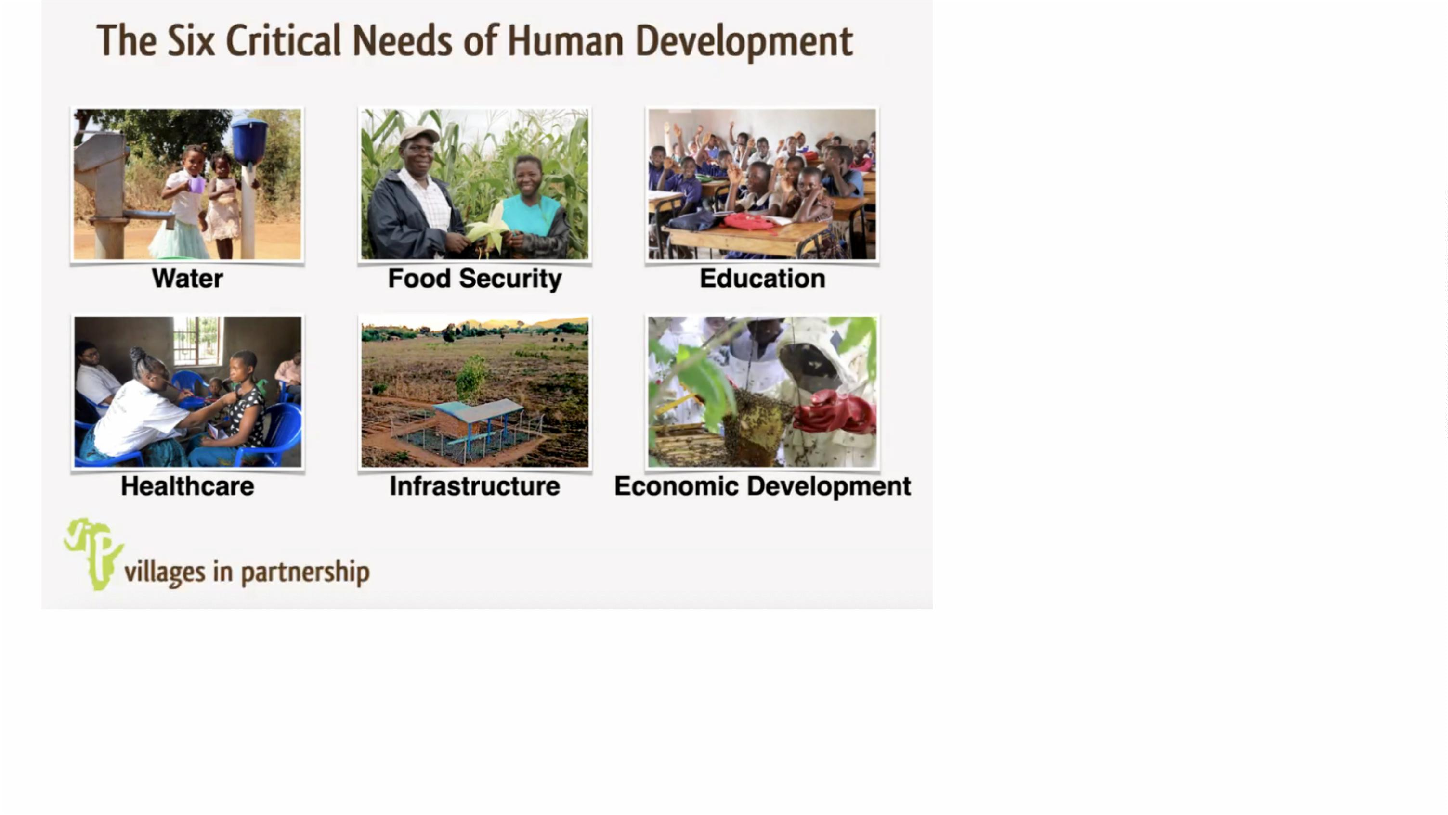

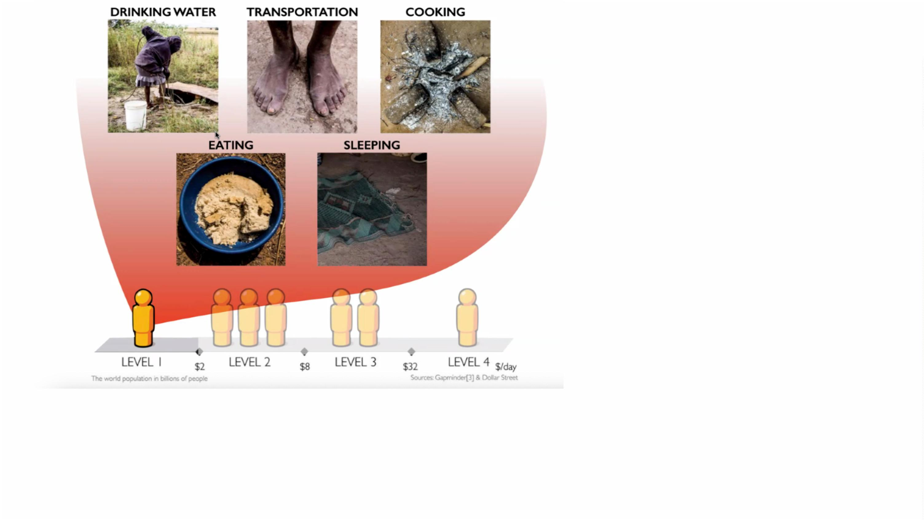

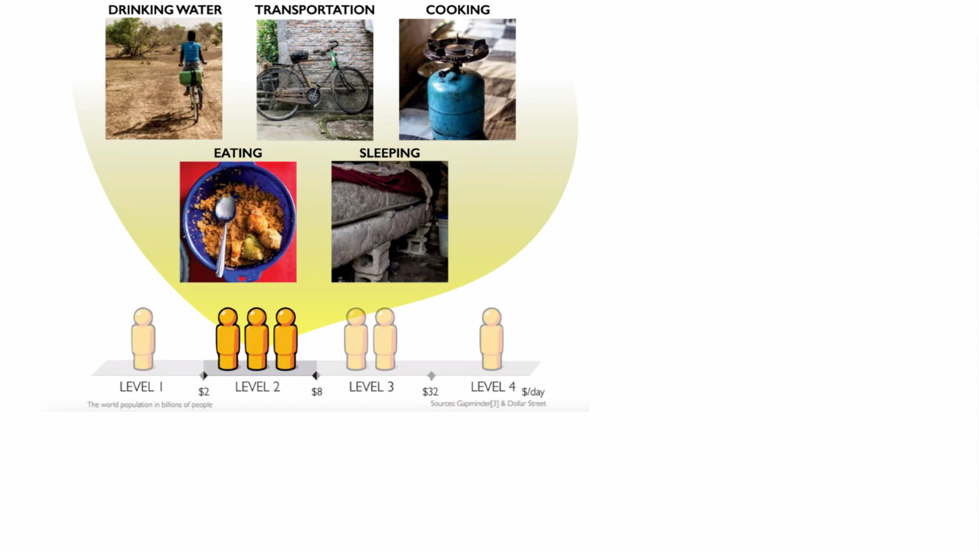

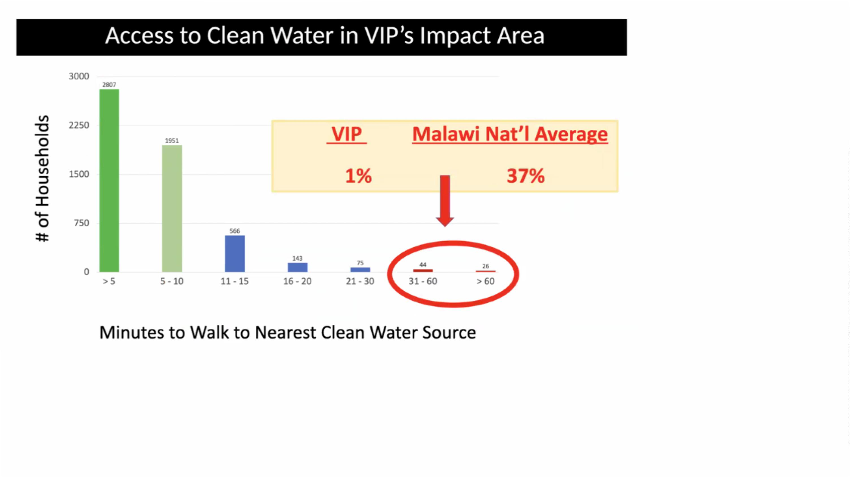

GlobalꢀWaterꢀGrant,ꢀonceꢀagain!
•
•
•
•
•
•
Whyꢀaꢀgrant?ꢀLeverageꢀupꢀtoꢀ$19.8KꢀinꢀDDFꢀandꢀWorldꢀFundꢀmatch
$50,000-ishꢀbudget
Fiveꢀwellsꢀ– toꢀbeꢀdrilledꢀthisꢀsummer
Zomba regionꢀofꢀMalawi
VIPꢀ- NGOꢀpartner
Blantyreꢀ- theꢀhostꢀclub


ExpectedꢀImpact
VIPꢀhasꢀidentifiedꢀfiveꢀvillagesꢀthatꢀfaceꢀaꢀshortfallꢀofꢀaboutꢀsevenꢀ
boreholesꢀofꢀMalawi’sꢀstandardꢀofꢀoneꢀboreholeꢀservingꢀ50ꢀhouseholds:
•
•
•
•
•
Manduwasa (460ꢀppl)
Makuluni (635ꢀppl)
Mmwala (1,405ꢀppl)
Maulana (890ꢀppl)
Maliwata (1,135ꢀppl)
Thisꢀprojectꢀwillꢀbenefitꢀaboutꢀ1,000-1,250ꢀpeopleꢀacrossꢀtheꢀfiveꢀnewꢀ
boreholes


ExpectedꢀImpact
EconomicꢀandꢀSocialꢀJustice
Aꢀnearbyꢀwellꢀcanꢀtransformꢀtheꢀsocialꢀstructureꢀofꢀaꢀcommunityꢀforꢀtheꢀ
better,ꢀespeciallyꢀforꢀwomenꢀandꢀgirls.
Girlsꢀnoꢀlongerꢀhaveꢀtoꢀspendꢀlargeꢀportionsꢀofꢀtheirꢀdayꢀfetchingꢀwaterꢀ
andꢀcanꢀgoꢀtoꢀschool.
Womenꢀsimilarlyꢀcanꢀspendꢀfreed-upꢀtimeꢀengagingꢀinꢀeconomicꢀ
opportunitiesꢀmoreꢀsuitedꢀtoꢀtheirꢀcapabilitiesꢀandꢀgoals.


Fundraising
Raisedꢀsoꢀfar:ꢀ
$
12,500 Downers Grove club (Int'l sponsor)
$
$
$
$
$
5,000 Rotary club of Aiken, South Carolina
1,000 DDF from Aurora United (6450)
1,000 Rotary club of Blantyre (host club)
1,500 Rotary club of Cape Charles, Virginia
1,000 Rotary club of Oak Park/River Forest (6450)
$
776 Rotary club of Naperville (6450)
$
6,507 Downers Grove Rotarians
$
10,000 DDF from 6450 (pending timely grant submission)
$
$
8,800 World Fund match (pending timely grant submission)
2,600 Non-Rotarian donations
$
50,683 Total


WhatꢀisꢀtheꢀUrgency?
•
•
•
•
•
“pendingꢀtimelyꢀgrantꢀsubmission”
DistrictꢀDDFꢀandꢀWorldꢀFundꢀmatchꢀisꢀ1_{st}-come,ꢀ1_{st}-served
Grantꢀsubcommitteeꢀmeetsꢀ21ꢀMar,ꢀneedsꢀ7-dayꢀleadꢀtime
Atꢀleastꢀ2ꢀotherꢀclubsꢀseekingꢀDistrictꢀDDF


WhatꢀisꢀtheꢀUrgency?
•
•
•
•
•
“pendingꢀtimelyꢀgrantꢀsubmission”
DistrictꢀDDFꢀandꢀWorldꢀFundꢀmatchꢀisꢀ1_{st}-come,ꢀ1_{st}-served
Grantꢀsubcommitteeꢀmeetsꢀ21ꢀMar,ꢀneedsꢀ7-dayꢀleadꢀtime
Atꢀleastꢀ2ꢀotherꢀclubsꢀseekingꢀDistrictꢀDDF
Andꢀofꢀcourse,ꢀmanyꢀpeopleꢀareꢀwaitingꢀforꢀtheseꢀwells!


HowꢀtoꢀPledge
•
Noꢀmoneyꢀisꢀneededꢀatꢀthisꢀtime--justꢀpledges.
•
Weꢀwillꢀbeginꢀcollectingꢀpledgesꢀonceꢀtheꢀgrantꢀisꢀapproved...inꢀaꢀmonthꢀorꢀ
two?
•
•
•
Fillꢀoutꢀaꢀpledgeꢀcardꢀandꢀgetꢀitꢀbackꢀtoꢀme
OR..ꢀLookꢀatꢀtheꢀproposalꢀinꢀtheꢀ“SPC”;ꢀseeꢀQRꢀCodeꢀonꢀcard.
Thinkꢀitꢀover,ꢀandꢀ...
•
•
Textꢀmeꢀatꢀ630-310-1464,ꢀor
Emailꢀmeꢀatꢀrotary@walquist.net


StrikingꢀWater
